System Requirements Document

BoatDock Application

Group 4

|  |  |  |
| --- | --- | --- |
| Name | Email | Roles |
| Muhammad Mohsin Qamar Khan | [muqm22@student.bth.se](mailto:muqm22@student.bth.se) | Requirement Elicitation,  Domain analysis,  SRS documentation |
| Syed Ali Hassan | [syal22@student.bth.se](mailto:syal22@student.bth.se) | Observation of domain,  Project Goals, stakeholder analysis |
| Muawaz Ayyaz | [muay22@student.bth.se](mailto:muay22@student.bth.se) | Quality requirements, Project scope |
| Sai Prakash Chakla |  | Quality Requirements, FunctionalRequirements |
| Muhammad Shahzaib | [musz22@student.bth.se](mailto:musz22@student.bth.se) | Data Requirements,Domain level Requirements |
| Hafiz Muhammad Sultan Afridi | [haaf22@student.bth.se](mailto:haaf22@student.bth.se) | Observation of domain,  Project Goals, stakeholder analysis |

Course: Requirement Engineering and Product Management

Project supervisor: KrzysztofWnuk,Vi

VERSION: Version V1.6 REVISION DATE: 09-12-2022

Contents

Section 1 Introduction: 4

1.1 Propose: 4

1.1 Scope: 5

1.2 Definitions, acronyms, and abbreviations 5

1.3 Overview 5

The above document gives the details specification for the BoatDockApp. 5

1.4 Goals of the product 6

1.5 Context diagram for the system 7

Section 2 Stakeholder Identification and analysis 7

2.1 User category: 8

Section 3 Requirements Elicitation Techniques 10

3.1 Elicitation Technique 1 (Observations): 10

3.2 Elicitation Technique 2 (Interview): 10

3.3 Elicitation Technique 3 (Brainstorming): 11

3.4 Elicitation Technique 4 (Reverse brainstorming): 11

Section 4 System Requirements 12

4.1 Domain Level Requirements: 12

4.2 Functional Product Level Requirements: 12

4.3 Data Requirements 19

4.4 Product Quality Requirements 23

Section 5 Requirement Prioritization: 24

5.1 MoSCow Technique: 24

5.2 Ranking: 26

Section 6: Release Plan: 29

6.1 First time release plan: 29

6.2 Project Back Log: 30

6.3 Development, Setup and Configuration: 32

6.4 User Management for Boat Dock App 33

6.5 System Integration Test (SIT): 33

6.5.1 Pre- Requisites: 33

6.5.2 SIT Scope: 33

6.6 Training: 33

6.7 UAT: 34

6.8 Cutover: 34

Section 7: Policy and Regulation Requirements 34

Section 8 References: 34

Section 9 Document Revision History 34

# Section 1 Introduction:

This Requirement specification document for a Boat Dock App for ABC group (ABC). ABC is a new in Sweden IT market. A company working on sustainable software system including ecommerce, sales and marketing. The proposed Boat Dock App management system will provide customer and moor owner to publish advertisement and moor dock place for customer, the user need to publish Add, search advertisement, browsing the moor catalog and ability to complete mooring hiring on-line with payment system. This document describes the scope, objectives and goal of the Boat Dock App. In addition to describing non-functional requirements, this document models the functional requirements with use cases, interaction diagrams, and class models. This document is intended to direct the design and implementation of the Boar Dock system.

## 1.1 Propose:

The purpose of this document is to provide all parties involved with a clear understanding of the scope of that is needed for the ABC Company– Boat Parking Web App. Upon ABC Company internal approval and signoff, this document will serve as an official project implementation document. When necessary, the document may be updated upon agreement. This document is based upon the following points that define the scope of the project. These points are critical to the overall Boat Parking Web App project schedule and budget. They are reflected in the intermediate project deadlines established by the project team. The following is a list of the major project points to be addressed by both the IT project team and ABC Company personnel.

Main functionality of Boat Mooring App:

* Possibilities to registration boat with length, width, height
* Search for the area for moor and must be specified price, distance time date and length, width and depth if not registered.
* Show available alternatives that are compatible with boat
* Information about the mooring price ,distance, revenue
* Costumer option to review the experience with rating
* In App Payment via various gateways
* System should be secure with login with OTP authentication
* Chat Option between Mooring Owner and customer

## 1.1 Scope:

The Scope of this system is an interactive web based system that support the marketing of location based Boat mooring and hospitality industry of Sweden and Nordic region. The system support directly redirect customer to mooring dock and its existing sales agent network.

The system invoices and account billing are not part of this project. The mobile app is also not part of BoatDockApp. The existing manual system will be replaced by BoatDockApp. In addition, changes to the logical and physical design of the databases are expected and cost will bear by the client. A web search engine and language translator will be obtained as purchased components for the BoatDockApp. Their internal details are not part of this project. Issues of website authentication and security are not part of this project.

# 1.2 Definitions, acronyms, and abbreviations

|  |  |
| --- | --- |
| **Term** | **Meaning** |
| ABC Company | ABC Company LLC: software company who is developing the application |
| Moor Owner | Boat Parking place owner |
| RE | Requirement Engineering |
| MC | Master card Scheme |
| Visa | Visa Card Scheme |
| SOA | Service Oriented Architecture |
| SOAP | Simple Object Access Protocol |
| ORM | Object Relational Mapping |
| OTP authentication | One time password/ two factor authentication code |
| Sale agent network | Sales and marketing persons |
| Available alternatives | Digital marketing |

# 1.3 Overview

The above document gives the details specification for the BoatDockApp.

**Section 2: Stakeholder Identification and analysis:** This section we lists the client for development the system. List of all stockholders and the group of interest of importance.

**Section 3: Requirements Elicitation Techniques:** This section lists the requirement elicitation techniques that you used and brief summary of particular technique.

**Section 4: System Requirement:** This section states the requirement at different levels domain and product design with data functional and quality in each level.

**Section 5: System Prioritization:** This section state the requirement prioritization techniques used by us to differentiate the requirements we have elicited in the above section.

**Section 6: Release Plan:** This section states the steps how we are going to release to our customers

**Section 7: Policy and Regulation Requirements:** This section states the domain policy and regulation implanted by the country/region/city where the business would run

**Section 8: References:** This section states the reading materials and articles used for developing the requirement document.

**Section 9: Document Revision History:** This section states the iteration of work done in making the document with versioning and which person working on what section.

# 1.4 Goals of the product

* The system shall allow for online rent a mooring place either by customer or sales agent /moor owner. This will eliminate the current delay between their decision to customer and the location owner this will reduce the time.
* Mooring place detail and description update within 30 seconds of the database being updated by the product owner. This will reduce the number incorrect location with Google Map API and this will also eliminates the redundant update of customer information.
* The system shall display all information of location, mooring place and price and other facilities associated with company. This feature will improve service by reducing the mean number of web pages a user must navigate per session to 10000 / user.
* The system allows ABC Company to view all owner of moor location. An customer / moor owner should able to contact to ABC company in one call/email to save time for correct any information
* The system should provide accounting with actual amount of transaction. This will improve the customer service reducing billing complain by 100% in correcting inaccurate account. Reports facilities provide for future uses.
* The system provides accurate location and places and agreement details so this will allow the order to be processed in intently and details updated within 10 seconds.

# 1.5 Context diagram for the system

Banner, deals, photo update, payment

Banner, deals, information

Approval, updates confirmation

User management, Agreement

Search, Agreement, payment details

Approve Agreement

Payment via debit credit card

Payment via debit credit card

Advertiser/Sales Agent

Web App Admin Team

Users

Payment System

# Section 2 Stakeholder Identification and analysis

We had an interview with our customer in which we gathered customers’ needs and customer expectations for the application. Through this, we analyzed and understand different type of user for our web application. The lists of stakeholders are listed below:

## 2.1 User category:

Different type of users in our system:

* **Travelers**: The user group travel on their personal boat around the cities and want to rent a mooring place for a short stay. These user need a mooring place near a hotel, restaurant and grocery store where they can buy items, rest and eat. The user can register and login as a customer to rent a mooring place for a short interval of time. Travelers can talk to the mooring place owner through chat after applying for the rental place in the application.
* **Mooring place owners**: the user category has a place to rent out for mooring place. The user can register and upload details of the mooring place he wants to rent out, and duration availability of the mooring place.
* **Harbor owner**: Harbor owner have a place of a big mooring place for rental where he has multiple mooring place for the boats. Big and small boats are moored in the harbor.
* **Boat owner**: Boat owner is a living resident in a city and wants a mooring place to his boat for a yearly basis.
* **Water Event Organization Company:** Water event Organization Company’s a company that organizes water sports and events for a particular season in a year. The company rents us multiple places for boats.

Harbor Owners, Mooring place owners are stakeholders which give out the place for rent and act as tenant. Boat owner, Water Event Organization Company, travelers are the stakeholders which register for applying for a mooring place to rent.

We also developed personas as to identify the user needs.

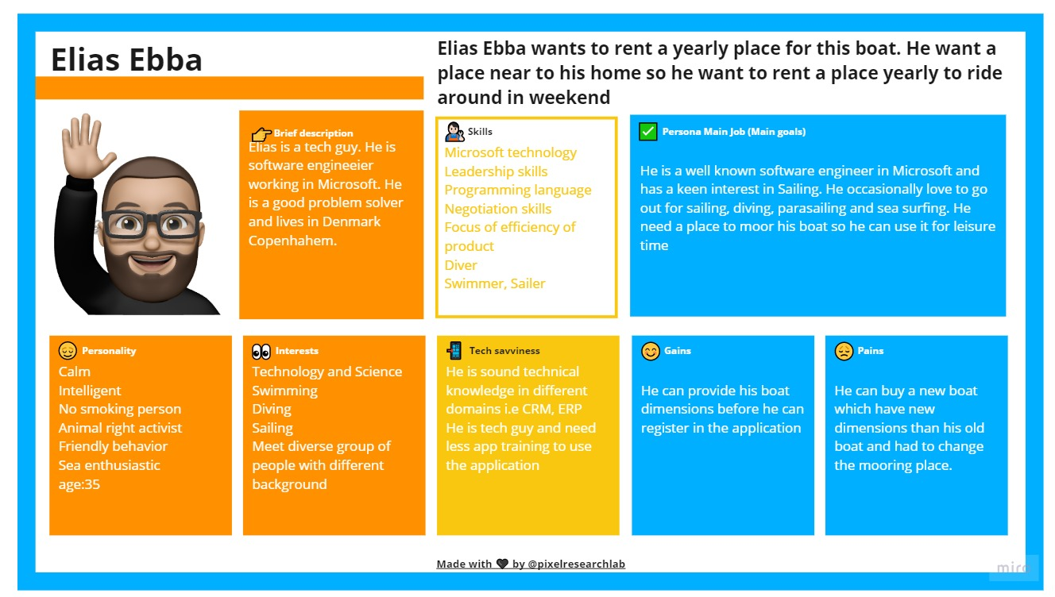

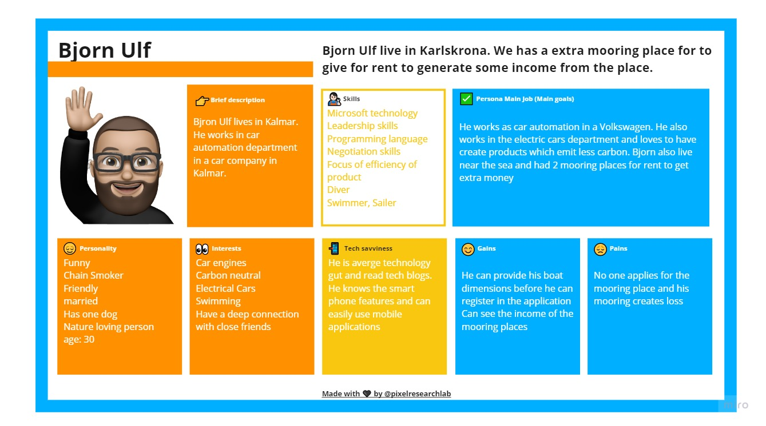

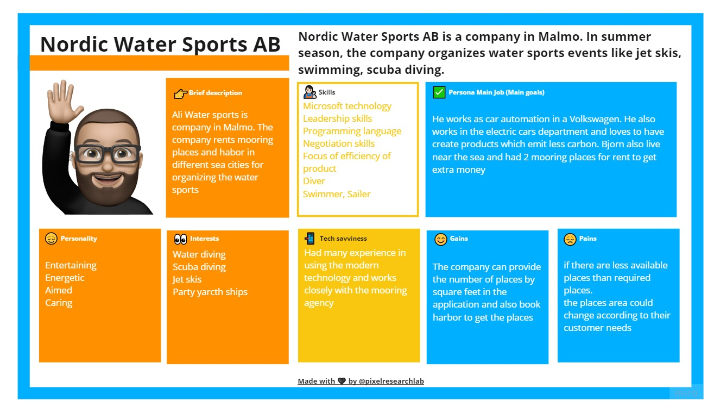

The total categorized into is defined below:

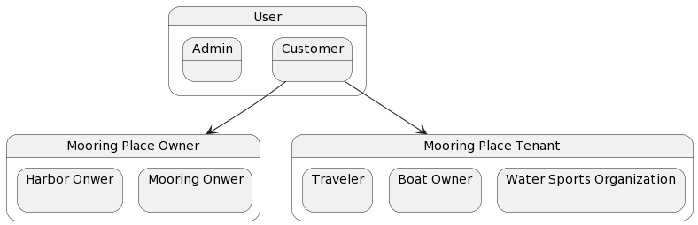

# Section 3 Requirements Elicitation Techniques

## 3.1 Elicitation Technique 1 (Observations):

Through initial requirement one-pager, we started to observe the business requirements of the system. We understand the stakeholder and observed how the system and business value would be developed in the system.

Why we used observation:

After getting project description one-page, we booked a face-to-face meeting with project owners to understand and get requirements. Before taking the interview, we understand the system and made some queries to better understand the system.

Requirements we get from this technique:

The list of requirements we get from this technique are:

* DL1,DL4,FR1,FR2,FR5,FR7,FR10

## 3.2 Elicitation Technique 2 (Interview):

We interview the product owners on 8 November 2022. We asked about the product business aspects and asked queries which we developed through observation elicitation technique. The interview was done in structured way, the agenda and the process of the interview was determined by us.

Why we used this technique:

Initially, we developed some queries in order to better understand the needs of the business domain. As we know using observation and interview technique together would provide us better understanding of the system and resolve our questions. Through interviews, we also defined the scope of the system by asking the product owners.

Requirements we get from the system:

* DL2,DL3,FR3,FR4,FR6,FR8,QR1,QR2

## 3.3 Elicitation Technique 3 (Brainstorming):

After completing the interviews, we elicit the business level, domain level and planned 2 brainstorming session of one hour in which every group member is involved. We had a session of 40 minutes in which we discussed the solutions from the requirements and developed the design of the system.

Why we used this technique:

After conducting the interview from the product owner, we needed to brainstorm the possible solutions of the requirements and design a model of the application.

Requirements we get from the system:

* DL5,DL6,FR10,FR14

## 3.4 Elicitation Technique 4 (Reverse brainstorming):

We did a session as teams in reverse brainstorming for our project in order identify the potential problem and address them and think about the possible solutions.

Why we used this technique:

We used this technique because we have a large system which are many user types. To remove any conflict of the user group’s requirements, we identified the issue through reverse brainstorming.

Requirements we get from the technique:

* FR9,FR11,FR12,FR13,QR4,QR5,QR6,DL4,DL2

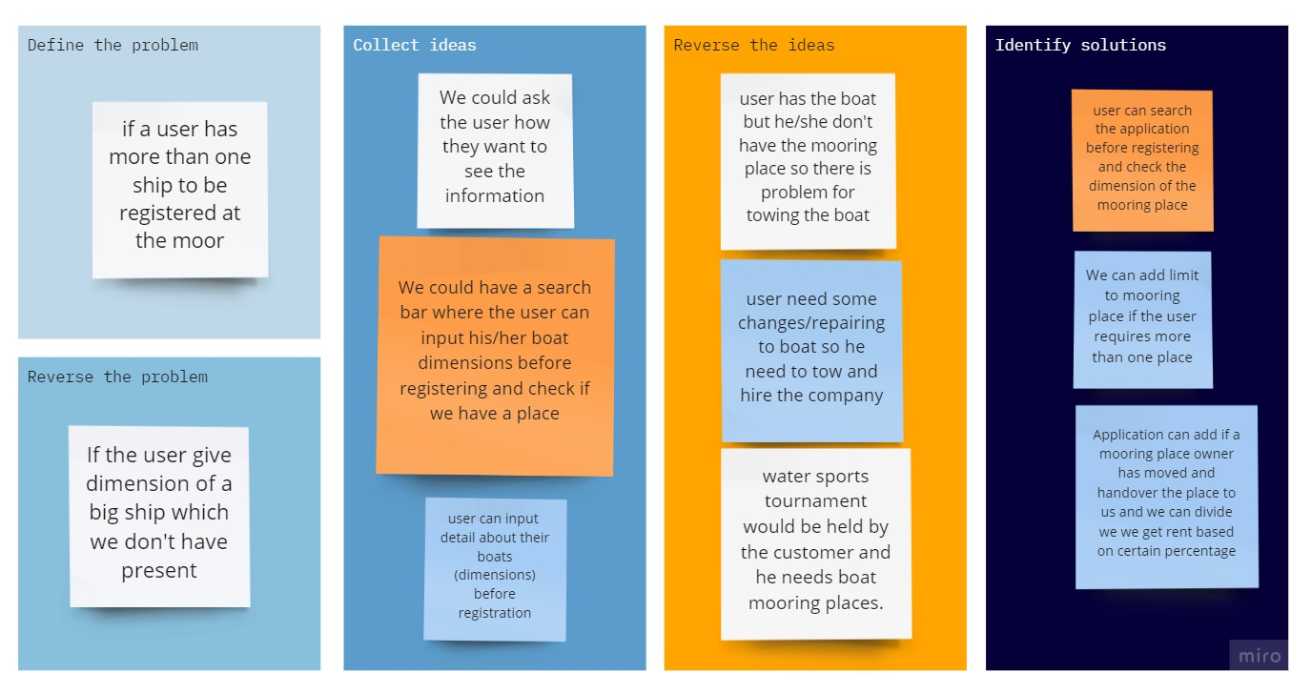

# Section 4 System Requirements

We used different techniques for system requirements. Through these techniques, we developed requirements of different levels.

## 4.1 Domain Level Requirements:

The Product shall support the following business user activities:

DL1: Product shall be able to allow the users to search information in the system.

DL2: Product shall be able to allow the users to pay for mooring place through in-app payment.

DL3: Product shall be able to allow the user to provide the rental contract of the mooring place.

DL4: Product shall be able to allow the users for provide the Mooring place information.

DL5: Product shall be able to allow the users to rate their experience.

DL6: Product shall be able to allow the user to register.

## 4.2 Functional Product Level Requirements:

We did 2 task descriptions and 2 use cases in order to define the functional product level requirements and added screens and prototypes

**Screens and prototypes:**

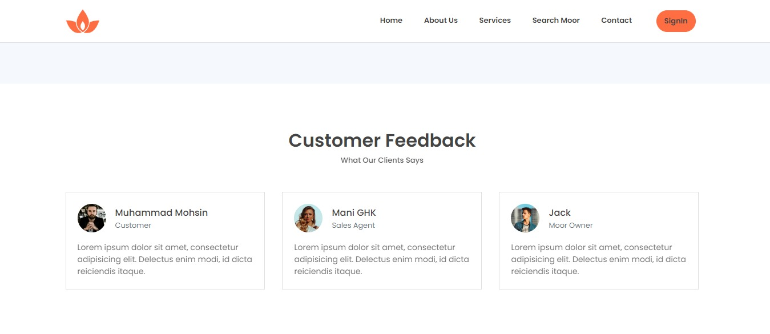

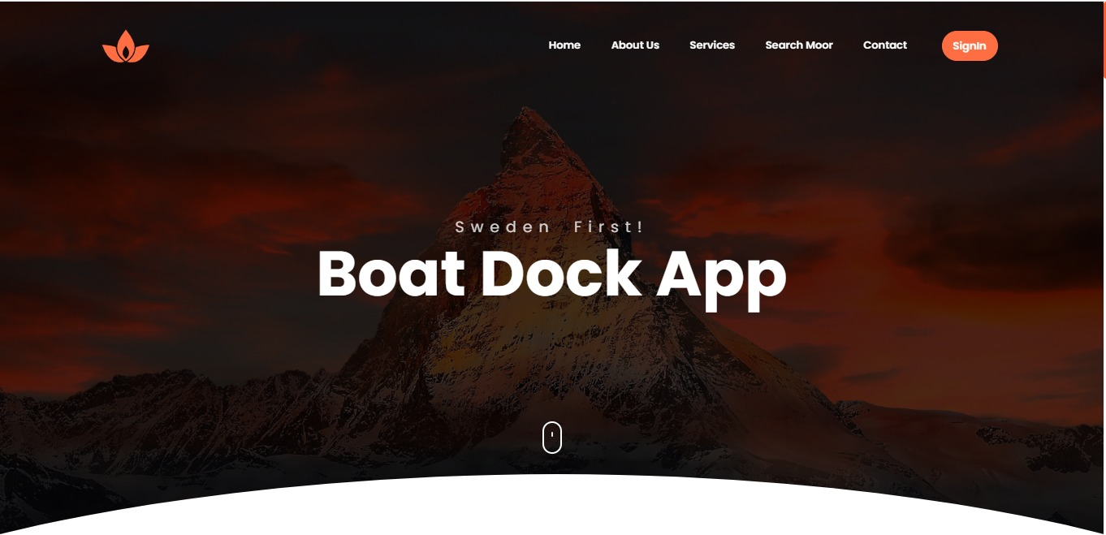

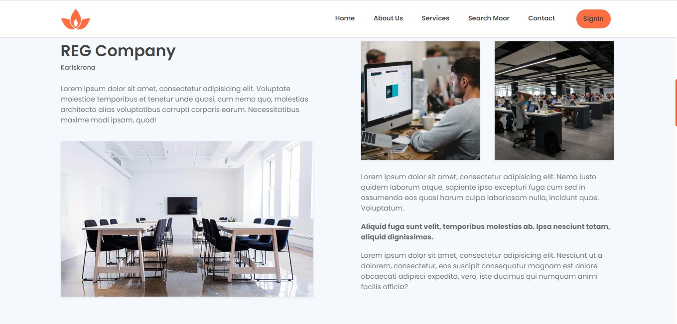

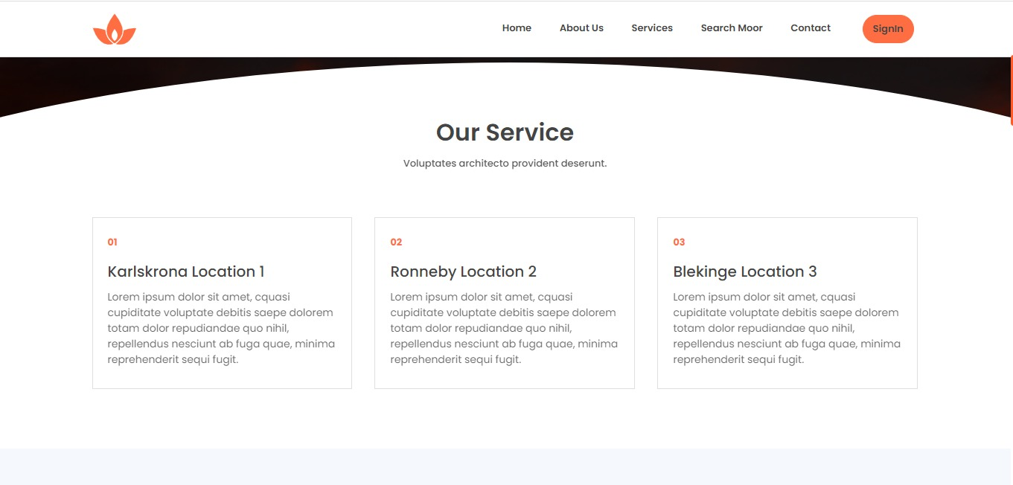

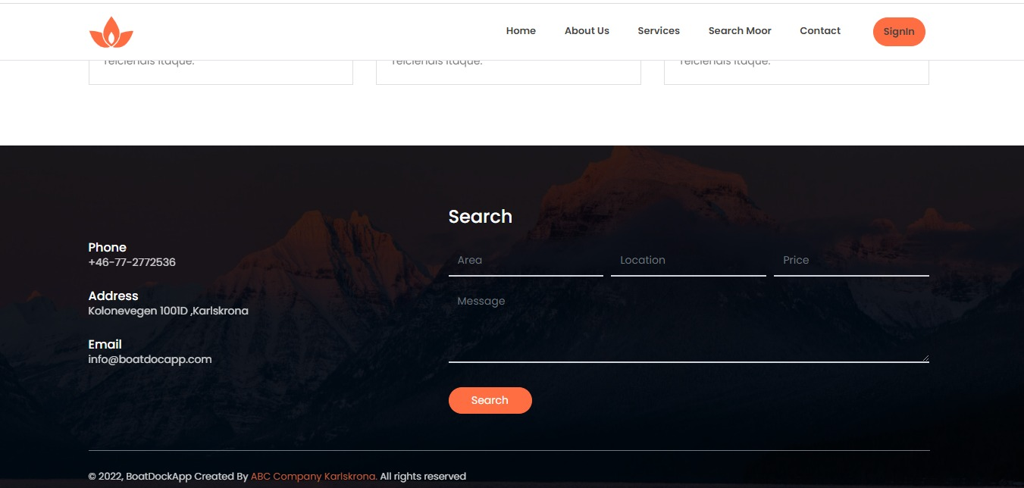

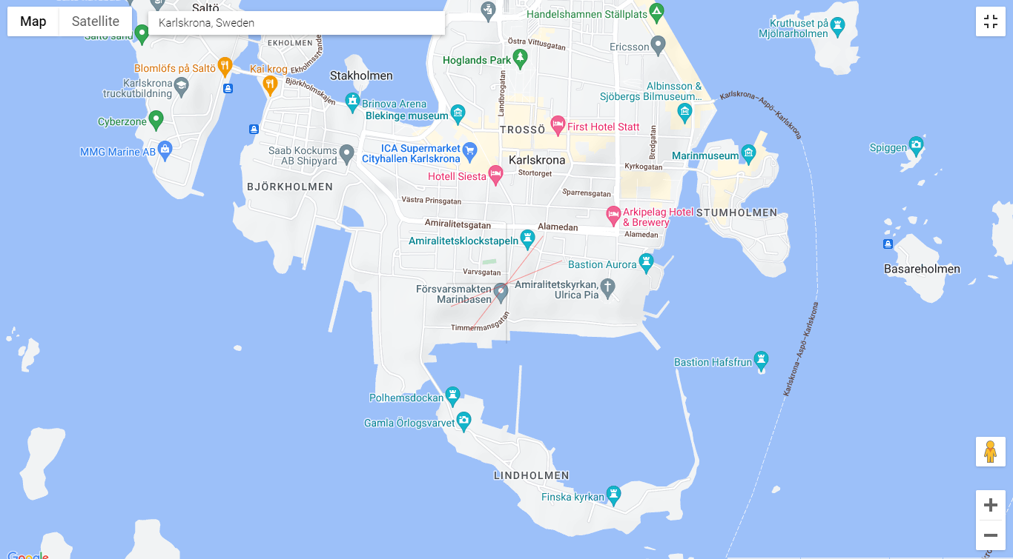

**Task Descriptions:**

|  |
| --- |
| **Task Name**: 1.1 Registration |
| **Purpose**: Registered customer to Mooring App  **Trigge**r:  **Precondition**: customer looks to mooring boats and registered first  **Frequency**: 0.6 customers / minute (customer use the application)  **Critical**: user already exsist/ user block /account marked suspecious |
| **Sub-tasks:**   1. Registered to application 2. Gives personal information 3. Geographical information |
| **Variants:**   1. User already exsist 2. False information 3. Authentication not confirm |

|  |
| --- |
| **Task Name**: 2.2 Searching for boat |
| **Purpose**: searching for the mooring place  **Trigge**r:  **Precondition**: customer client search for mooring places by region/ county  **Frequency**: 0.6 average per day  **Critical**: no mooring places available /booking full |
| **Sub-tasks:**  1) first search the moor by using boar specification  2) contact to owner about more details  3) provide document for contract and other fomalaties  4) Deal confirmation |
| **Variants:**   1. Moor arleady accupied by others 2. Places is not good for mooring boat 3. Hotels / facilities too far away from boat |

**Use Cases:**

|  |  |
| --- | --- |
| **Use Case Name** | 1.1 Customer Registration |
| **Brief Description** | Customer/user registered to applicaiton / login to App |
| **Actors** | Customer/ Moor Owner/ client |
| **Precondition** | User need user id and password to access the App |
| **Basic flow** | 1)Customer download the applicaton  2) Customer registered to application by providing user email / password  3) Cusotmer recieved confirm |
| **Alternative flow** | 1)Customer call to Support  2)provide information and registered. |
| **Exit conditions** | Logout from application |

|  |  |
| --- | --- |
| **Use Case Name** | 1.2 Search for Mooring Boat |
| **Brief Description** | Customer search for the mooring place |
| **Actors** | Cusotmer /client /moor owner |
| **Precondition** | Already search for the boat /User access the application via user id/ password |
| **Basic flow** | 1. Customer search for mooring place by filteres 2. Find places by customer deals/ cheap prices 3. After find place need to contact owner for details 4. Sign contract and payment |
| **Alternative flow** | Customer email to Mooring agency for registration and mooring place by mooring place ID /code |
| **Exit conditions** | Logout from application |

|  |  |
| --- | --- |
| **Requirement No** | **Search feature for users** |
| PR1 | The user shall be able to search mooring places by entering details by search by city/location/area name in the search box |
| PR2 | The user shall be able to view the hotels, restaurants, leisure places and petrol pump near the mooring place in the maps. |

|  |  |
| --- | --- |
| **Requirement No** | **Rental place payment** |
| PR4 | The User shall be able to enter payment details in the application |
| PR5 | The User shall be able to pay the mooring place rent an through in-app payment gateway |

|  |  |
| --- | --- |
| **Requirement No** | **Register and contract** |
| PR3 | User shall be able to select the mooring place and apply for registering |
| PR6: | User shall be able to select download the rent contract |
|  |  |

|  |  |
| --- | --- |
| **Requirement No** | **Mooring place** |
| PR7: | User shall be able to add multiple mooring places in the system |
| PR8: | User shall be able to approve renting request in to the mooring place owner |
| PR14: | User as a mooring place owner shall be able to view the rental request of the mooring place. |

|  |  |
| --- | --- |
| **Requirement No** | **User Rating** |
| PR9: | Mooring place Tenant shall be able to rate the mooring place experience after the rent time |
| PR10: | Mooring place owner shall be able to rate the mooring place tenant |

|  |  |
| --- | --- |
| **Requirement Type** | **User Registration** |
| PR11: | User shall be able to enter name, age , contact no, address, postal address into the system |
| PR12: | User shall be able to enter boat dimensions (length, width and height) in its user profile |
| PR13: | User shall be able to select the duration of rent by days to rent out mooring |
| PR 16: | User shall be able to add the length, width and height of their boat in registration |

PR15: ABC Company shall be able to check the activities of user if user does violate company rules and regulations

## 4.3 Data Requirements

We used data dictionary, one prototype and ER model diagram to get data requirements of the system. We are doing rational data base as we can define class ad entity relation model which suits our Object oriented approach.

**Data Dictionary:**

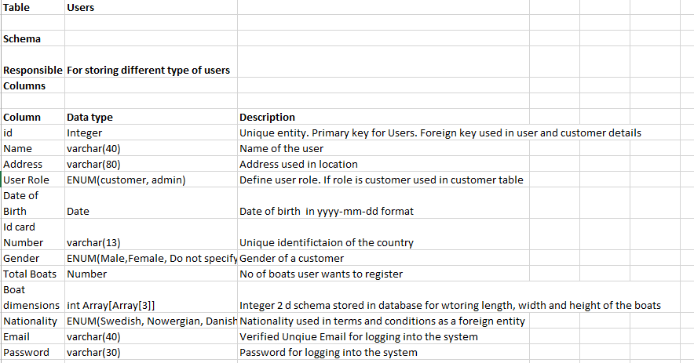

**E/R Model:**

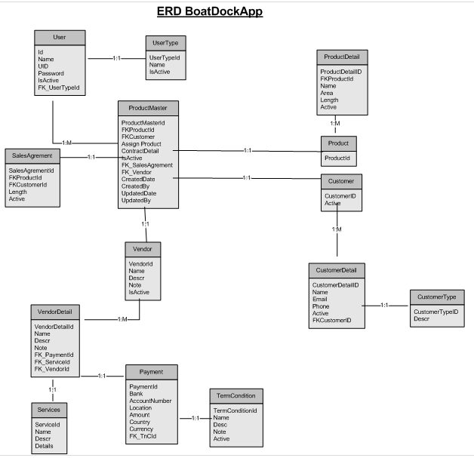

**DR1:**

**Data table: User**

User unique data is saved into the system. All stakeholders/users type data is saved into the system

**Attributes:**

Id: Integer (Primary key)

Name: varchar (50)

DOB: Date

Nationality: varchar (50)

Phone: varchar (12)

Email: varchar (40)

Password: varchar (20)

UserRole: Integer (Foreign Key)

**DR 2:**

**Data Table: terms and conditions**

Lesser shall be able to add the terms and conditions of the mooring place. System admin can add the terms and conditions of the county/country lawn place

**Attributes:**

Id: Integer (Primary Key),

Name: varchar (30),

Description: varchar (200),

Details: varchar (500)

**DR3:**

**Data Table Payment details:**

Boat owner/travelers are pay through in app payments to the rent.

**Attributes:**

PaymentId: Integer

Bank: varchar (11),

Account ID: varchar (18)

Location: varchar (14)

Amount: Number

Currency: String

TryCid: Integer (Foreign key)

**DR4: Product Details**

Travelers/boat owners can enter boat dimensions while registering into the system. Mooring place owners can enter their mooring place dimensions.

**Attributes:**

ProductId:Integer

Name

ProductDetail

Area

Length

Active

## 4.4 Product Quality Requirements

We used QUPER Model for getting the performance requirements. We also measured the cost/benefit of developing features in house or integrating it with 3rd party.

**QUPER Model:**

**Creation:**

1. **Quality Aspect:**

* **Performance:** System response time for each page (5 Sec)

1. **Reference list/ competitors**

* **Canal & River Trust: (**Take 2 sec)

1. **Quality Break points**

* **Utility:** 4 Sec: All page load time
* **Differentiation:** 3Sec : Filtration activate
* **Saturation:** 2sec: Mooring Place booked

1. **Barriers**

* **Steep cost: 5 sec:** payment system
* **Steep Cost: 3 sec**: new architecture

1. **Target**

* **Good: 3 Sec:** This target is possible to create an own payment system without using third party service.
* **Stretch: 3 Sec:** If new S/w Architecture is feasible.

**Road Map:**

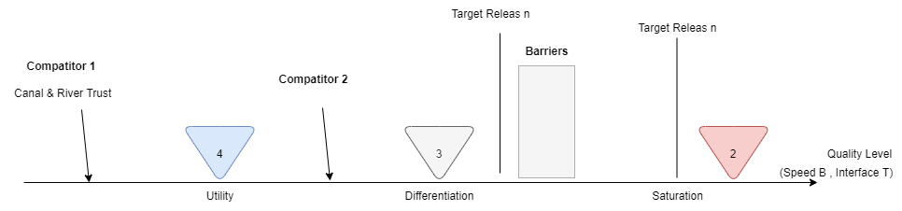

**Reliability:**

QR1: System must be reliable to maintain its working for At least 1 million users at a time.

QR2: System must be fault Tolerance and ensure that work properly during fault detection.

QR3: System should be available 22 hours every day 97.3%.

**Availability:**

QR4: System must be available 24*7 hour and must have less than 1 mint down time within a week/month.

**Performance:**

QR5: System response time of every page must not in less than2 sec.

QR6: All the applied filters must generate result less than 2 sec

**Maintenance:**

QR7: System must be modifiable at any time in future to be existing features.

# Section 5 Requirement Prioritization:

We interview the product owners a second time to elicit and finalize our requirements. In our requirements. We understand our private mooring place owner and mooring are our main stakeholder and thus there requirements are our considered high priority requirements. We decided to use 2 techniques MoSCow technique and Priority Group Techniques. Our first

## MoSCow Technique:

In this section we have prioritized the product-functional level requirements through the MoSCow technique.

MoSCow technique divides the requirements into 4 categories: Must have, Should have, Could have and would have giving priority respectively. We applied the technique and MoSCow priority hierarchy is as follow:

**Product Function Requirements:**

The product functional are being prioritized

**Must have:**

|  |
| --- |
| PR8: The user shall be able to approve renting request in to the mooring place owner |
| PR14: The user as a mooring place owner shall be able to view the rental request of the mooring place. |

PR3: The user shall be able to select the mooring place and apply for registering

PR 16: The user shall be able to add the length, width and height of their boat in registration.

**Should have:**

|  |
| --- |
| PR1 The user shall be able to search mooring places by entering details by search by city/location/area name in the search box |
| PR2 The user shall be able to view the hotels, restaurants, leisure places and petrol pump near the mooring place in the maps. |

PR13: The user shall be able to select the duration of rent by days to rent out mooring

|  |
| --- |
| PR11: The user shall be able to enter name, age , contact no, address, postal address into the system |
| PR12: The user shall be able to enter boat dimensions (length, width and height) in its user profile |

**Could have**:

PR6: The user shall be able to select download the rent contract

**Would have:**

|  |
| --- |
| PR4: The user shall be able to enter payment details in the application |
| PR5:The user shall be able to pay the mooring place rent an through in-app payment gateway |
| PR9: The mooring place Tenant shall be able to rate the mooring place experience after the rent time |
| PR10: The mooring place owner shall be able to rate the mooring place tenant |

PR7: The user shall be able to add multiple mooring places in the system

**Quality Requirements:**

**Must have:**

|  |
| --- |
| QR3: System should be available 22 hours every day 97.3%. |
| QR4: System must be available 24*7 hour and must have less than 1 mint down time within a week/month. |

**Should have:**

|  |
| --- |
| QR5: System response time of every page must not in less than 2 sec. |

**Could Have:**

QR6: All the applied filters must generate result less than 2 sec

QR1: System must be reliable to maintain its working for At least 1 million users at a time.

**Would Have:**

QR7: System must be modifiable at any time in future to be existing features

## 5.2 Ranking:

We prioritize the requirements by assigning numerical values to them 1 being the most important and n being the least important in the system. The product level and quality requirements are stated below:

**Product-Level Requirements:**

|  |  |
| --- | --- |
| **Requirement SR no.** | **Ranking** |
| PR1 The user shall be able to search mooring places by entering details by search by city/location/area name in the search box | **7** |
| PR2 The user shall be able to view the hotels, restaurants, leisure places and petrol pump near the mooring place in the maps. | **5** |
| PR4 The User shall be able to enter payment details in the application | **11** |
| PR5 The User shall be able to pay the mooring place rent an through in-app payment gateway | **12** |
| PR3 User shall be able to select the mooring place and apply for registering | **3** |
| PR6: User shall be able to select download the rent contract | **10** |
| PR7:User shall be able to add multiple mooring places in the system | **15** |
| PR8: User shall be able to approve renting request in to the mooring place owner | **1** |
| PR14: User as a mooring place owner shall be able to view the rental request of the mooring place. | **2** |
| PR9: Mooring place Tenant shall be able to rate the mooring place experience after the rent time | **14** |
| PR10: Mooring place owner shall be able to rate the mooring place tenant | **13** |
| PR11: User shall be able to enter name, age , contact no, address, postal address into the system | **8** |
| PR12: User shall be able to enter boat dimensions (length, width and height) in its user profile | **9** |
| PR13: User shall be able to select the duration of rent by days to rent out mooring | **6** |
| PR 16: User shall be able to add the length, width and height of their boat in registration | **4** |

**Quality Requirements:**

|  |  |
| --- | --- |
| **Requirement SR no.** | **Ranking** |
| QR1: System must be reliable to maintain its working for At least 1 million users at a time. | **7** |
| QR2: System must be fault Tolerance and ensure that work properly during fault detection. | **6** |
| QR3: System should be available 22 hours every day 97.3%. | **1** |
| QR4: System must be available 24*7 hour and must have less than 1 mint down time within a week/month. | **2** |
| QR5: System response time of every page must not in less than2 sec. | **4** |
| QR6: All the applied filters must generate result less than 2 sec | **3** |
| QR7: System must be modifiable at any time in future to be existing features. | **5** |

**Conclusion of 2 Prioritization technique used:**

In the above section, we used the 2 techniques Ranking and MoSCow techniques to prioritize our product functional and quality requirements. We analyzed and concluded that Ranking is better in prioritizing our requirements as it would make clear understanding which requirements need to develop early and release through our release planning. As we are using Agile (Scrum) model, the ranking will give better understanding which requirements should be released in the product backlog.

We will use the Ranking technique for the release planning of the product.

# Section 6: Release Plan:

For our Boat Dock App we use agile methodology for our release plan. The system should divided into four sprints of two week each with milestones representing the expected release dates. The release initiative has divided into software developers consist of (front-end/back-end) , DB team and QA team. The major software development team involved in each sprints according to priority level, making clear plan for both stockholders and product development team.

## 6.1 First time release plan:

For initial first time high level release plan we shall plan as per following factor

1. **Releasing**- Here we are plan BoatDockApp. Is it a fully responsive web application hosted on web hosting server by HosterPK and has database on MS SQL server.
2. **Requirements**- as per the first time release plan we provide following main features
   1. Web Application with Dashboard
   2. Search filter
   3. Location setup
   4. Bank configuration
   5. Dock mooring setup
   6. Maker Checker capability
   7. Rent Agreement
   8. SMS /OTP Confirmation
   9. Payment Confirmation /Email Configuration
3. **Goals & Expectations**- we ensure that system shall be working after first release. SIT with banking transaction must be complete before first release.
4. **Prioritize Product Backlog**- We shall be priorities the task by managing product backlog. Below is product backlog sheet.

## 6.2 Project Back Log:

|  |  |  |  |  |  |  |
| --- | --- | --- | --- | --- | --- | --- |
| **Id** | **Sprint** | **Theme** | **As a/an** | **I want to** | **So that** | **Priority** |
| PR8 | 1 | Boat Dock App | Traveler, boat owner | User shall be able to approve renting request in to the mooring place owner | user should view request | High |
| QR3 | 1 | Boat Dock App | Admin | System should be available 22 hours every day 97.3%. | admin should able to view | High |
| QR4 | 1 | Boat Dock App | Admin | System must be available 24*7 hour and must have less than 1 mint down time within a week/month. | admin should able to view | High |
| QR6 | 1 | Boat Dock App | Traveler, boat owner | : All the applied filters must generate result less than 2 sec | admin should able to view | High |
| PR14 | 1 | Boat Dock App | Traveler, boat owner | PR14: User as a mooring place owner shall be able to view the rental request of the mooring place. | owner should chat with tenant | High |
| PR3 | 1 | Boat Dock App | Traveler, boat owner | PR3 User shall be able to select the mooring place and apply for registering | receive payment from mooring place | High |
| PR16 | 1 | Boat Dock App | Traveler, boat owner | PR 16: User shall be able to add the length, width and height of their boat in registration | search mooring place by key word | High |
| PR2 | 1 | Boat Dock App | Traveler, boat owner | PR2 The user shall be able to view the hotels, restaurants, leisure places and petrol pump near the mooring place in the maps. | search mooring place by location filter | High |
| PR13 | 1 | Boat Dock App | Traveler, boat owner | PR13: User shall be able to select the duration of rent by days to rent out mooring | apply for rental place | High |
| PR1 | 1 | Boat Dock App | Traveler, boat owner | PR1 The user shall be able to search mooring places by entering details by search by city/location/area name in the search box | registration to app | High |
| PR11 | 2 | Boat Dock App | Traveler, boat owner | User shall be able to enter name, age , contact no, address, postal address into the system | owner should view total revenue | Medium |
| PR12 | 2 | Boat Dock App | Traveler, boat owner | User shall be able to enter boat dimensions (length, width and height) in its user profile | view profile for tenant for verification | Medium |
| PR6 | 2 | Boat Dock App | Traveler, boat owner | User shall be able to select download the rent contract | view rating of the place | Medium |
| PR4 | 3 | Boat Dock App | Traveler, boat owner | The User shall be able to enter payment details in the application | view previous rating for mooring place | low |
| PR5 | 3 | Boat Dock App | Traveler, boat owner | The User shall be able to pay the mooring place rent an through in-app payment gateway | view all type of restaurant and hotels nearby mooring place | low |
| PR10 | 3 | Boat Dock App | Traveler, boat owner | Mooring place owner shall be able to rate the mooring place tenant | admin shall be view total number of registered user in BoatDockApp | low |
| PR9 | 3 | Boat Dock App | Traveler, boat owner | Mooring place Tenant shall be able to rate the mooring place experience after the rent time | view user by category | low |
| PR7 | 3 | Boat Dock App | Mooring place Owner | User shall be able to add multiple mooring places in the system | login to system by admin rights | low |
| QR5 | 3 | Boat Dock App | Mooring place Owner | System response time of every page must not in less than2 sec. | update dashboard by admin rights | low |
| QR7 | 3 | Boat Dock App | Mooring place Owner | System must be modifiable at any time in future to be existing features. | user must be category by admin | low |
| QR2 | 4 | Boat Dock App | Traveler, boat owner | System must be fault Tolerance and ensure that work properly during fault detection. | update mooring place and service after the rental agreement | low |
| QR1 | 4 | Boat Dock App | Traveler, boat owner | System must be reliable to maintain its working for At least 1 million users at a time. | responsive application open via mobile phone /tablet | low |

## 6.3 Development, Setup and Configuration:

The Boat Dock App proposed by software project team for ABC Company. all product setup for company along with a comprehensive web hosting services from HosterPK Web Hosting Server. Development, Product and associated surround system interface setups will be done first. For the initial release we had plan to deploy the app on web hosting server that can manage by our support team.

## 6.4 User Management for Boat Dock App

User Creation will be done by EN Team for both the interfaces. Bank will be required to share the list of users and User Security Matrix both for test and live.

## 6.5 System Integration Test (SIT):

### 6.5.1 Pre- Requisites:

System Integration testing will be carried out in product team premises. ABC Company team to initiate and configure transactions from Boat Dock app. Payment Transaction (Incoming) transactions will have to be initiated from Master Card/Visa Card Scheme .Following System/resources will have to be arranged by ABC Company for this testing:

* VPN Connectivity between Development Server/Main Server and ABC Company
* All existing channels (BoatDock App, MasterCard ,Visa ,Swift pay ) availability on Test Environment.
* Test accounts/cards (total 04) for each product and account type should be available on test environment.
* Network connectivity between inter-related systems
* SFTP access (between product team and ABC Company)
* Test Environment connected
* Ready to support all transactions.
* Ready with test data of All types of cards/customers
* Test Swift Accounts (IBAN/Non-IBAN)

### 6.5.2 SIT Scope:

* All channels Positive, negative and exception transaction cases testing
* Card personalization end to end
* Account Management
* Response code mapping with BoatDock App , MC and Visa Card
* Transaction monitoring Testing
* Reports and EOD extracts

## 6.6 Training:

End User Training will be provided for

* Stakeholder
* Tech supporting staff

## 6.7 UAT:

UAT cycle will begin after training session. ABC Company team to share the UAT plan with product team and must make sure all pre-requisites are available. UAT sign off and Advice to Go Live will be shared upon Completion of UAT.

## 6.8 Cutover:

On successful conclusion of UAT, cutover plan will be published and discussed with ABC Company for Production release.

# Section 7: Policy and Regulation Requirements

* RP1: The product should interact with the Country’s national tax agency to identify the user credit score.
* RP2: The product shall support in-app payment verified through Bank ID.
* RP3: The Product shall support verifying user boat license data
* RP4: The product shall support verifying mooring place owner place details
* RP5: The product shall support option to view terms and conditions of the mooring place guidance and regulatory terms and conditions

# Section 8 References:

|  |  |
| --- | --- |
| [1] | A. Hudaib, "Requirements Prioritization Techniques Comparison," *Modern Applied Science,* vol. 12, pp. 1913-1844, 2018. |
| [2] | M. Suiab, "Requirment Elicitation Technique :- A Review Paper," *International Journal of Computer & Mathematical Sciences,* vol. 3, no. 9, pp. 2347-8527, 2014. |

# Section 9 Document Revision History

|  |  |  |  |
| --- | --- | --- | --- |
| Version | Date | Name | Description |
| 1.0 | 10-11-2022 | Muhammad Mohsin, Syed Ali Hassan, Muawaz Ayyaz, Hafiz Muhammad Sultan | First version of the SRS document. We started working on section 1 on the document |
| 1.1 | 12-11-2022 | Sai Parkas Chakla, Syed Ali Hassan, Muhammad Shahzaib, Hafiz Muhammad Sultan | We did analysis of the domain and written the elicitation techniques we are going to use in the document |
| 1.2 | 14-11-2022 | Muhammad Mohsin, Syed Ali Hassan, Muhammad Shahzaib, Sai Prakash, Muawaz Ayyaz, Hafiz Muhammad Sultan | After interview with the product owners, we started writing system requirements |
| 1.3 | 17-11-2022 | Muhammad Mohsin, Syed Ali Hassan, Muhammad Shahzaib, Sai Prakash, Muawaz Ayyaz, Hafiz Muhammad Sultan | We finalized the version 1 with complete system requirements |
| 2.1 | 08-12-2022 | Muhammad Mohsin/Syed Ali Hassan | Reference Updating/ Policy and Regulation Requirements |
| 2.1 | 09-12-2022 | Syed Ali Hassan/Muhammad Mohsin | Release Plan/Back Log sheet |
| 2.1 | 09-12-2022 | Muhammad Mohsin/Syed Ali Hassan | Update Backlog / content page |
| 3.1 | 06-01-2023 | Muhammad Mohsin/Syed Ali Hassan | Update the Domain level requirements and product level requirements |
| 3.1 | 06-01-2023 | Muhammad Mohsin/Syed Ali Hassan | Update the requirements prioritization section |
| 3.1 | 06-01-2023 | Muhammad Mohsin/Syed Ali Hassan | Update the release planning section |
| 3.1 | 06-01-2023 | Muhammad Mohsin/Syed Ali Hassan | Update the overview section in the document |